**User Doc**

***RedSun Clock*** is a smart clock based on ATmega328p. The RedSun Clock uses a beautiful dot matrix as the display module and makes it easy to read the time and information.

1. ***Design and architecture***

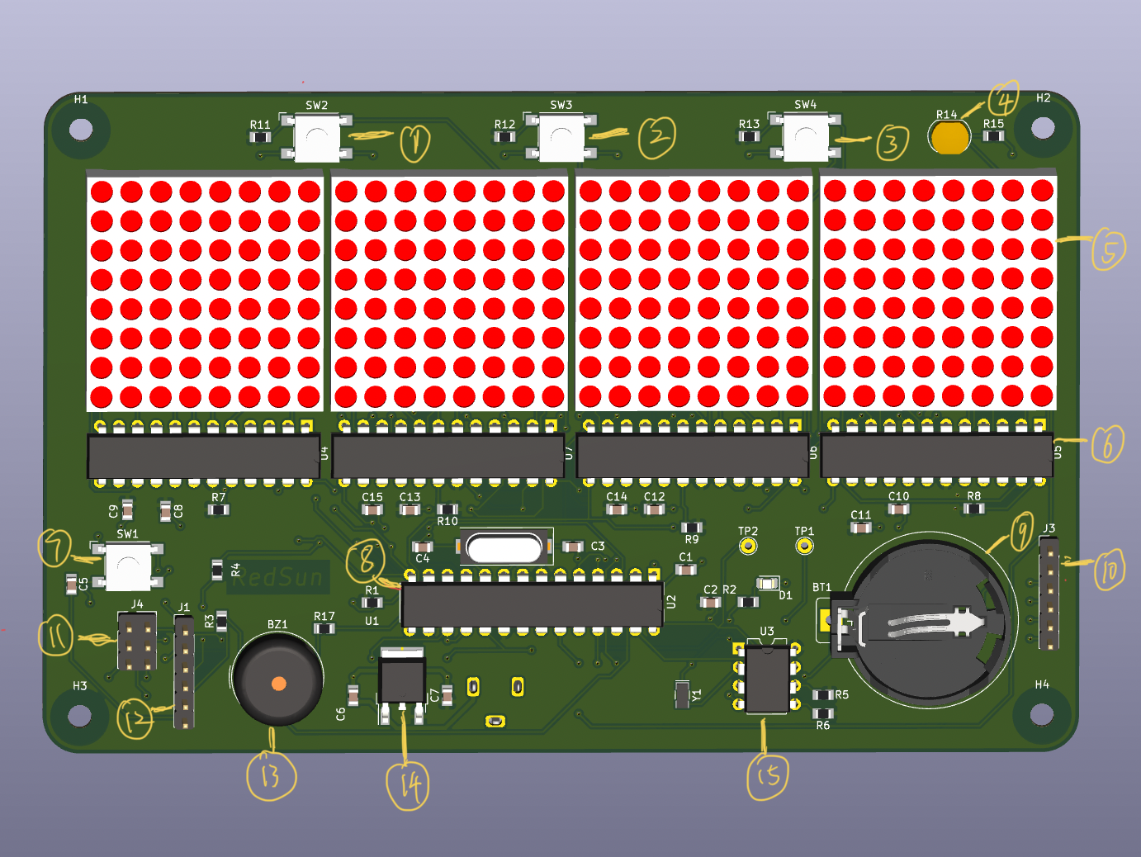

（Front 3D View of RedSum Clock）

* 1.Up/Daytime button
* 2.Down/ Datetime button
* 3.Sel/ Seconds button
* 4.Photoresistor
* 5. 8*8*4 dot matrix display
* 6. Max7219 chip(display processing chip)
* 7. Reset button
* 8. ATmega328P chip(micro controller)
* 9. Battery for RTC(real time clock)
* 10. Serial pins for joysticker
* 11. I/O pins
* 12. Serial pins
* 13. Alarm buzzer
* 14. Power management chip
* 15. DS1307 module (RTC)

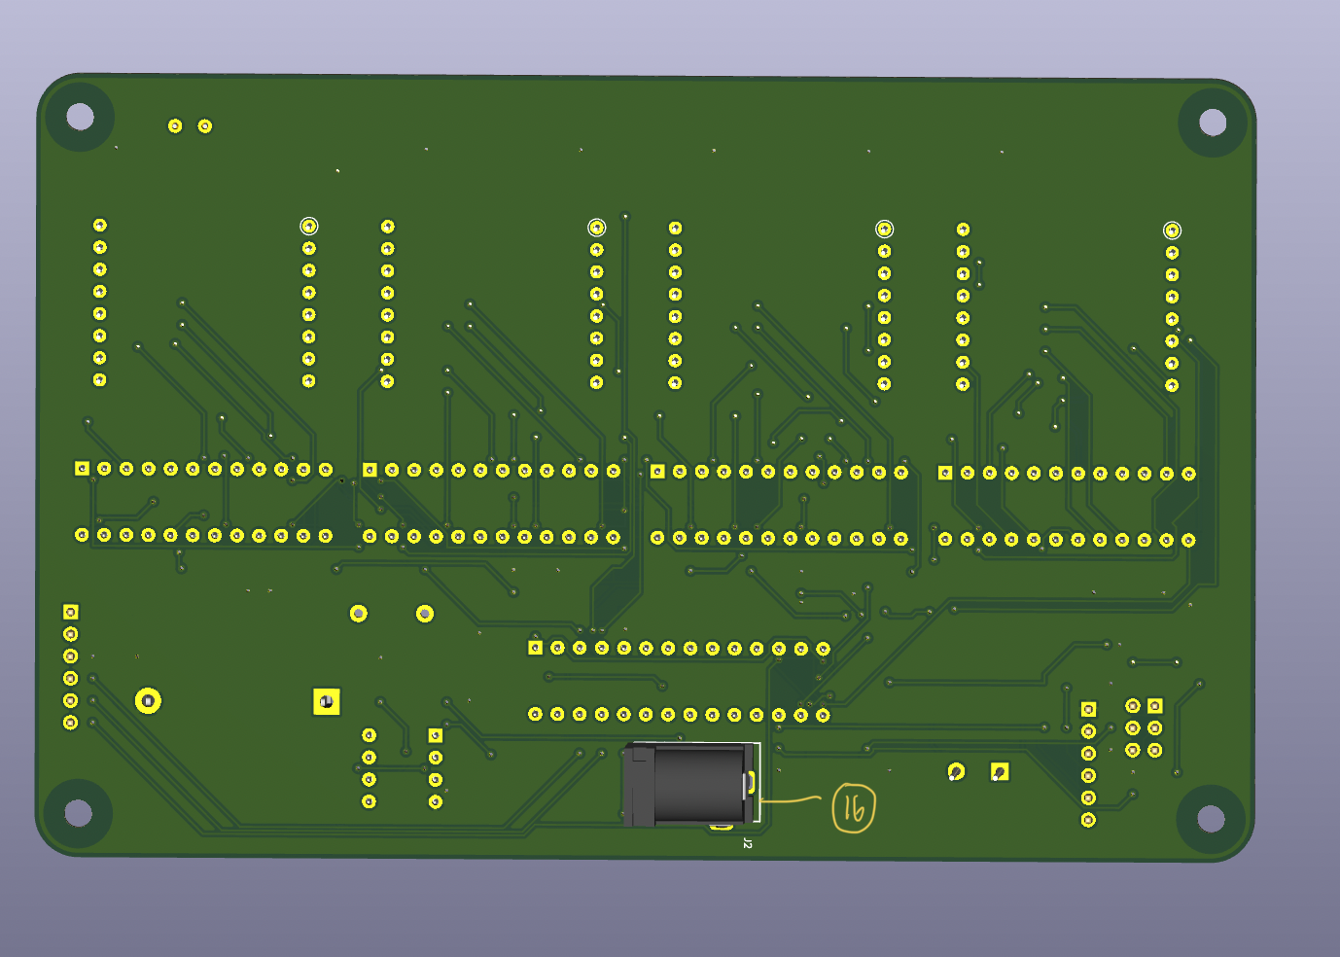

(Back 3D View of RedSum Clock)

* 16. Power supply

1. ***End-User Guide (Functions, charges, requirements)***

**Functions:**

Time display function: When the RedSun Clock is powered on, the time will be automatically displayed on the display module. If you need to display Datetime, please press (2-button). If seconds need to be displayed, press (3-button).

Alarm Clock Function: The alarm clock function can be used when the RedSun Clock is powered on. To use the alarm function, press the Joysticker first, then the RedSun Clock will display "00:00" (if other content is displayed, please refer to the common question section). Once the screen correctly displays "00:00", the user can use the joysticker to set the time of the alarm. joysticker up increases the time and down decreases the time. To the left or to the right is to switch between hours and minutes. When the alarm is set, press the joysticker again and the alarm will be saved.

**Charges：**

A 9v battery can be used to provide power or a round interface charger with a power adaptor. Do not touch the circuit in the energized state to avoid electric shock or short circuit.

**Requirements：**

1. Please keep your RedSun Clock in a dry and ventilated environment. Please also avoid direct sunlight.

2. It is necessary to install a RedSun Clock into the plastic case.

3. If the RedSun Clock overheats, please disconnect the power promptly.

Please do not touch the circuit board with conductors or live objects.

1. ***Source code address and simple code address***

**Code resource:** <https://github.com/YuWei-CH/Yuwei_Clock/tree/main/Code/ClockCode>

**Test code link:** <https://github.com/YuWei-CH/Yuwei_Clock/tree/main/Code/Test>

*(If there is a functional problem on RedSun Clock, you can use the Test code to troubleshoot it.)*

1. ***Test guide***

**If users have solid knowledge of EE and CS, they can use Test plan to self-test.**

**0. Visual Inspection:**

1.Mechanical Damage

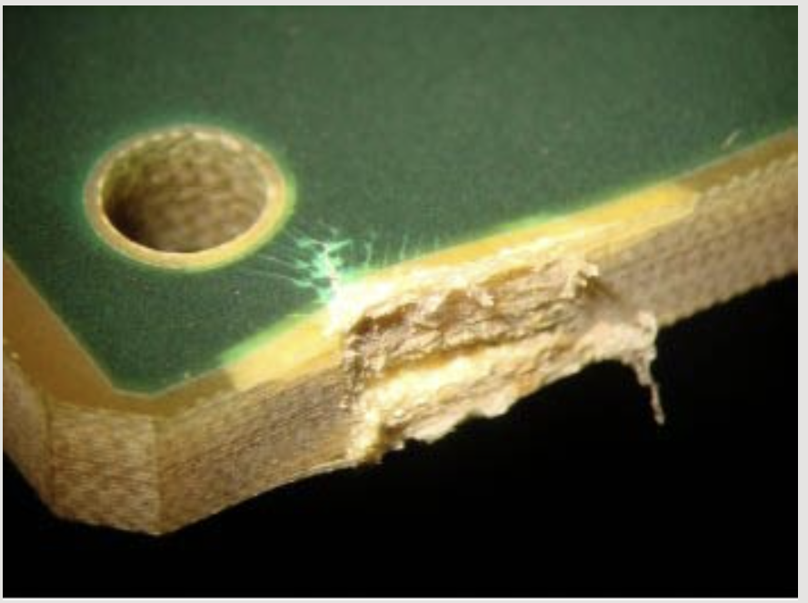

2.Copper Scratches

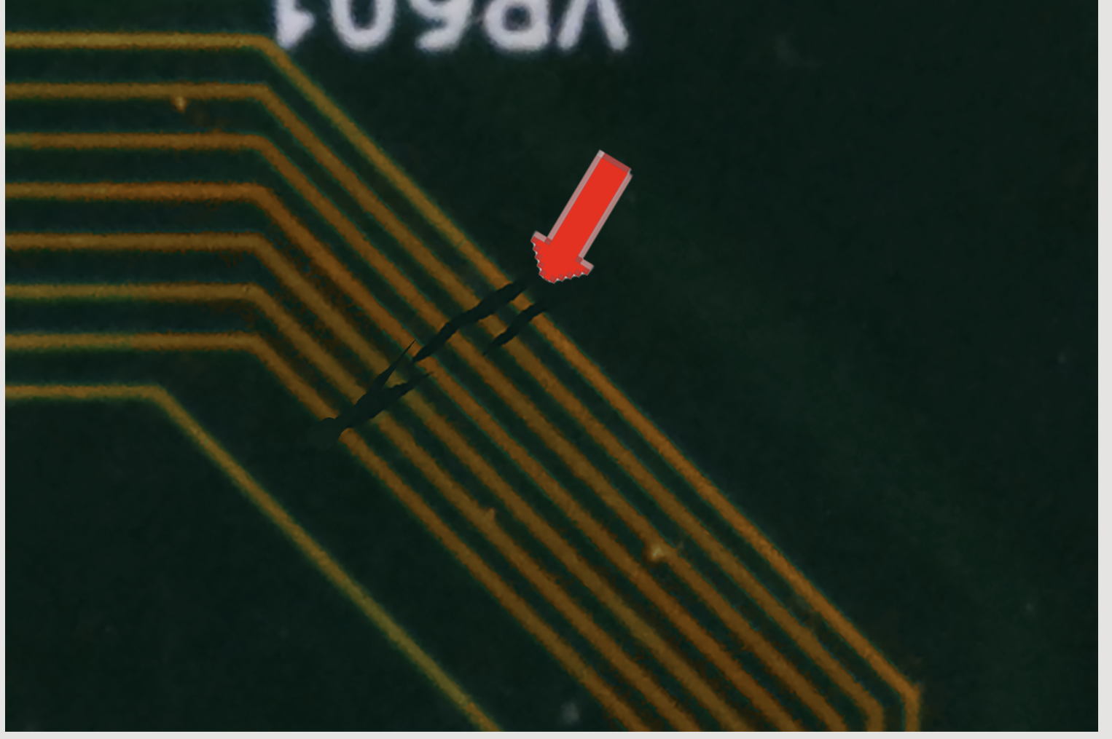

3.Solder Bridging

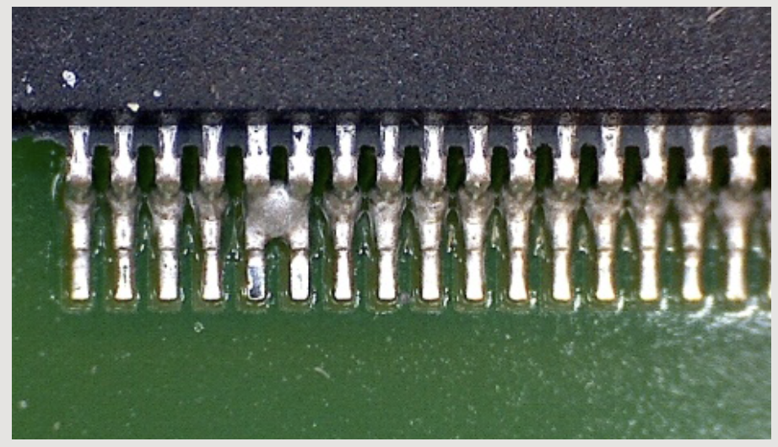

4.Cold Solder Joint

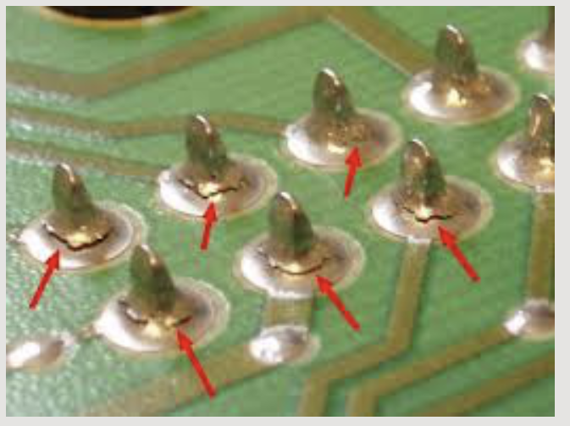

**1. LED:**

1.Test power and luminance of LED.

2.Run LED_blink code to test LED and Button

**2. Button:**

1.4 pins of the button are intact and working properly.

**3. DS1307:**

1.Can be powered by the breadboard

2.Battery works properly

3.You can use the 3 tests of Memory.ino

4.Capable of accurate time feedback (9600)

5. Touch the test pin with a voltmeter, the voltmeter should show the value

**4.Dot matrix:**

1. Test by “double for-loop print” which lights up each dot one by one, test whether each dot can be properly displayed.

2. Light up each row and test if there are any short circuits.

3. Call the display function to display the number.

4. Test the code in Dot_matrix_display

**5. Buzzer:**

1.Make sure it can sound through run code buzzer code

**6. Joysticker:**

1.Toggle the joysticker in all four directions and observe the values displayed by Serial.

2.Press the joysticker to make sure the value of SW in Serial has changed.

**7. Power:**

1.Use a voltmeter to connect the test pin next to the power supply, the voltmeter voltage reading should be 5v-9v

**8. Basic Function:**

Run the code in Yuwei_Clock/Code/Test one by one. Each component should have a corresponding reaction, for example, the LED will blink and Dot_matric will show the pattern.

**9.Advance Function:**

1. Does the Dot matrix display the correct time (hour:minute)?

2. Does the dot matrix display the date time (month/day/year) when the middle button is pressed?

3. Does the dot matrix show seconds after pressing the right button?

4. Does the dot matrix turn dark after covering the photoresistor with your hand?

5. Does the LED light up when the joysticker is pressed?

6. After pressing the joysticker, the system will enter the alarm setting mode. Is the dot matrix displayed correctly when moving the joysticker up and down and left and right?

7. After the alarm is set, does the buzzer go off at the alarm time and turn off within 4 seconds?

1. ***Help guide && Common questions and problems***

**What to do if the alarm clock does not display:** First, please restart RedSun Clock to ensure that the power supply is working properly. If there is no response after reboot, please press 1-button. if you have completed the above operations, you can try upload test code to troubleshoot the problem.

**The clock displays the wrong content:** If the content displayed is digital you can update the program again to reset the RTC.

**Inaccurate time:** Please check if the RTC battery is properly powered. If the displayed number is three digits, please refer to question 2.

**The button is not responding:** Please restart RedSun Clock to reset the hardware system. If there is no response after reboot, please check if the pins of the button are broken and if there are scratches on the circuit board under the button. If the problem persists, it is a hardware issue.

**Joysticker is not responding:** Please check if the Pins are properly connected. secondly, you can check if there is a short circuit in the connection of joysticker.

**The alarm clock is not responding:** First, please try to reset the alarm clock. If it still does not respond you can follow the order of (buzzer, joysticker and RTC) to check if the hardware is intact. If the hardware is intact, please upload the test code about the alarm to troubleshoot the problem.

**The alarm clock can not be turned off automatically:** first of all, it is recommended to turn off the RedSun clock, and then you can check whether the buzzer is short-circuited. If there is no problem, please re-upload the program.

**What to do if you get an error writing the program:** Please update the environment of Arduino IDE. Go to Arduino and click update one by one in the managed libraries window. If you have any problems with the program, please leave a comment on Github.